Monday  2/3/20 | Art  Social Studies Test
Tuesday  2/4/20 | Gym
Wednesday  2/5/20 | Media Center
Thursday  2/6/20 | ISM
Friday  2/7/20 | Music  Bagel Day  6:00 Movie Night
Social Studies
People & Culture
Test Monday, Feb. 3rd
Canada

Science
Human Body
Spelling
Unit 4 Week 3
disgraceful unsuccessful
outlandish outsider
incorrectly enjoyment
disappointment discouragement
enforcement repayment
enclosure unselfish
unhappiness disapproval
unfairness reminder
designer departure
delightful unevenly
competition national
original displeasure
informal
You can study on
www.spellingcity.com/mlarson19

Writing
Passage Based Writing (PBW)
Math
Math 6- Fractions & Decimals
Advance- Percents

Reading
Facing the Storm
Making Predictions
Theme
Realistic Fiction

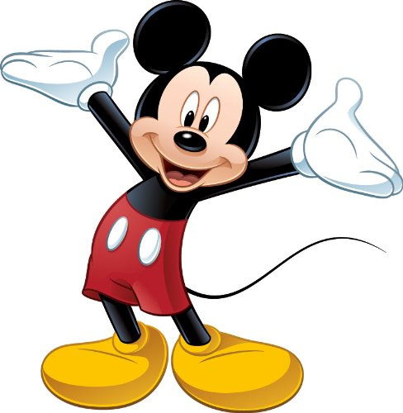

Upcoming Weekly Events

Larson’s Letter
Room 4, January 31, 2020

