Monday  1/27/20 | Art  6:00-8:00 Roller Skating Party
Tuesday  1/28/20 | Gym
Wednesday  1/29/20 | Media Center
Thursday  1/30/20 | ISM
Friday  1/31/20 | Music
Spelling
Unit 4 Week 2
compete competition
moment momentous
crime criminal
refer reference
nation national
metal metallic
final finality
reside resident
origin original
ignite ignition
admission division
decision acquire
acquisition
You can study on
www.spellingcity.com/mlarson19
If you did not turn in your behavior and expectation sheet signed, please do so on Monday. Also please turn in conference notes ASAP. Thanks!
Writing
Passage Based Writing (PBW)
Math
Math 6- Numerical Expressions & Factors
Tentative Test Date Jan 29th
Advance- Fractions & Decimals
Tentative Test Date Jan 30th

Social Studies
People & Culture
Test Monday, Feb. 3rd
Science
Human Body
Reading
NWEA Testing
The Rockers Build a Soccer Field
Realistic Fiction
Theme
Context Clues

Context Lues
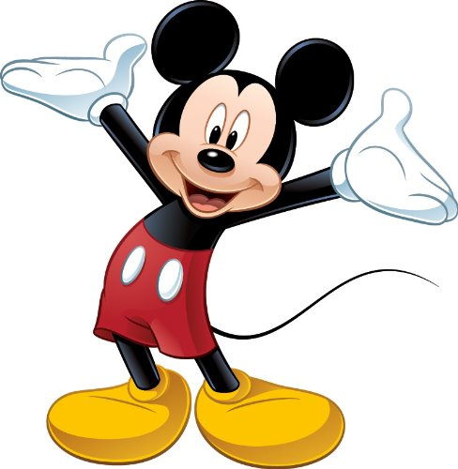

Upcoming Weekly Events

Larson’s Letter
Room 4, January 24, 2020

